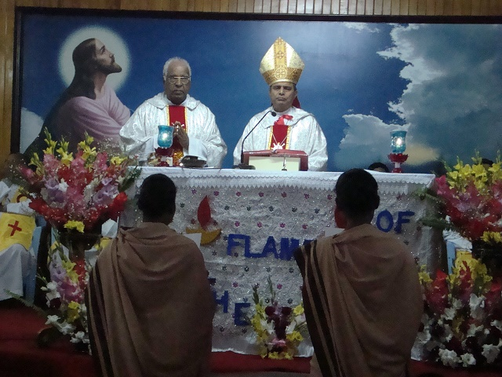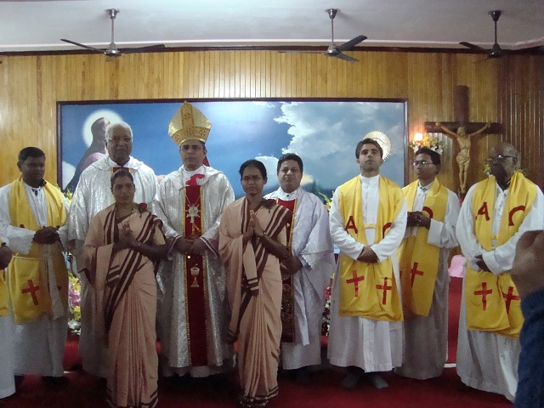
Children of Nav Jyoti School for the Visually Impaired at the Choir during the First Profession of Srs. Olrica Beck & Sangeeta Hembrom
